11/12/2019

Jun Yang LEE(Jayden)

South Metropolitan TAFE

Test Document

Programming III AT3

# Contents

Contents 1

Test Table 2

Debugger 4

# Test Table

|  |  |  |
| --- | --- | --- |
| **Case** | **Description** | **Screenshot** |
| 1 | Create User ( Sign Up) |  |
| 2 | Login Process (If matched will open up music player) |  |
| 3 | Music Player form |  |
| 4 | Buttons for the music player(First, Next, Previous, Last, Add, and Delete) |  |
| 5 | Sort Button | Unsort  Sorted |
| 6 | Export to CSV |  |
| 7 | Search button |  |

# Debugger

**Debugging on Last Button**

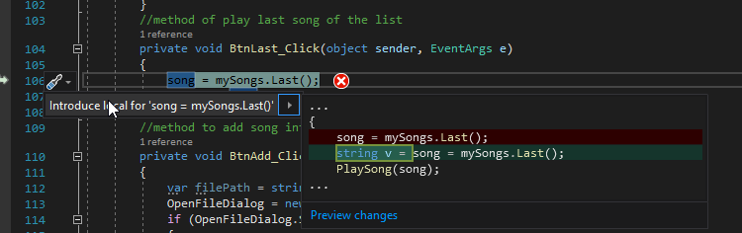

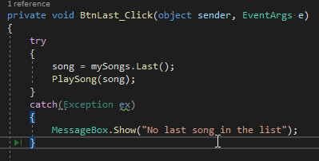

**Debugging during sorting algorithm**

